**Asiqul Hoque**

**Section 6 Lesson 2: Single-Row Subqueries**

**1. SELECT first_name,last_name,salary**

**FROM employees**

**WHERE department_id =**

**(SELECT department_id**

**FROM departments**

**WHERE department_id=80)**

**AND salary > 4200**

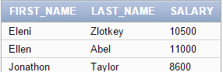

2. Write a query to return all those employees who have the same job id as Rajs and were

hired after Davies.

**SELECT first_name,last_name,job_id,hire_date**

**FROM employees**

**WHERE job_id = 'ST_CLERK'**

**AND hire_date > TO_DATE('29-JAN-1997','DD-MON-YYYY')**

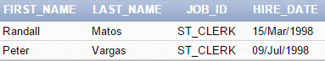

3. What DJs on Demand events have the same theme code as event ID = 100?

**select name,description**

**from d_events**

**where theme_code = 200**

**AND id = 100**



4. What is the staff type for those Global Fast Foods jobs that have a salary less than those

of any Cook staff-type jobs?

**select staff_type**

**from f_staffs**

**where salary<(select salary from f_staffs where staff_type='Cook')**



5. Write a query to return a list of department id’s and average salaries where the

department’s average salary is greater than Ernst’s salary.

**SELECT department_id, salary**

**FROM employees**

**WHERE salary <**

**(SELECT AVG(salary)**

**FROM employees)**

**AND salary > 6000;**

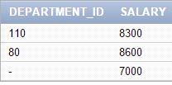

6. Return the department ID and minimum salary of all employees, grouped by department

ID, having a minimum salary greater than the minimum salary of those employees whose

department ID is not equal to 50.

**select department_id, min(salary)**

**from employees**

**group by department_id**

**having min(salary)>(select min(salary) from employees**

**where department_id!=50);**

